Assignment Submission Transaction Flow

Introduction
Transactional workflows coordinate multiple tasks performed by people and software systems to ensure that a process is completed accurately, consistently, and without loss of information. As Silberschatz, Korth, and Sudarshan (2001) explain, transactional workflows extend traditional transaction concepts to coordinated, multi-step activities that require correctness, integrity, and durability across the entire process. This discussion explains the assignment submission transaction flow, which involves both human participants, such as the student and professor, and automated systems, such as the learning management system and plagiarism checker, working together to move the assignment through a series of defined steps.

Components of the transaction flow
Figure 1 shows the assignment submission transaction flow. The entities involved in this transaction workflow include the student (human), the LMS (software system), the plagiarism detection system (software), and the professor (human). The activities encompass submission, notification, plagiarism detection, similarity index evaluation, decision-making (accept/reject), downloading, grading, and grade notification.

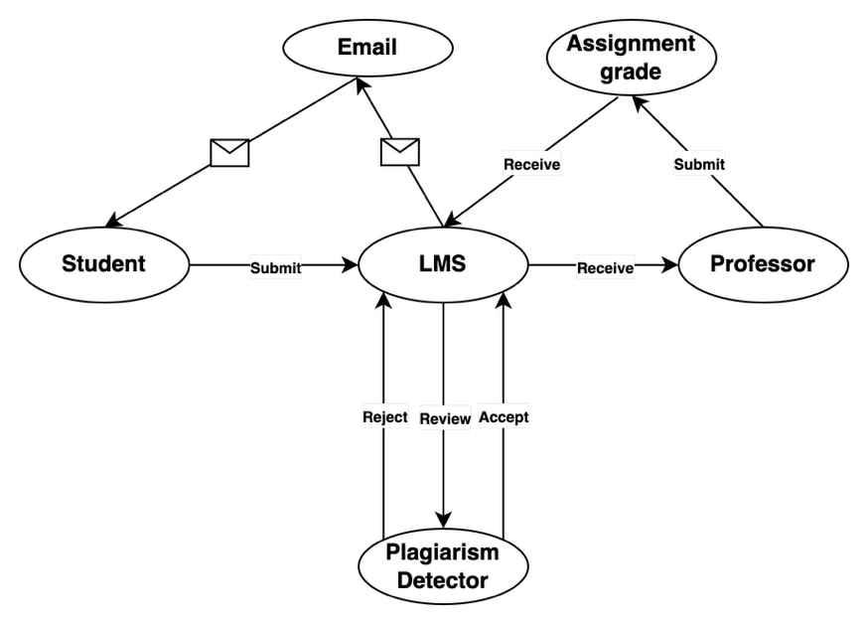
Figure 1
How it works
The assignment submission workflow begins when a student submits their assignment through the Learning Management System (LMS). Upon successful submission, the student receives an email notification confirming the submission was received. The LMS then automatically forwards the assignment to the plagiarism detection system for review. This system analyzes the submitted files to calculate a similarity index, comparing the content against a database of existing works. Once the plagiarism check is complete, the student receives an email containing the plagiarism report with the similarity index percentage.
The workflow then branches based on the similarity index. If the similarity index exceeds 10%, the assignment is automatically rejected and returned to the LMS. The student would then need to revise and resubmit the assignment. This review process typically takes 5-10 minutes, depending on the number of files being analyzed for similarity.
If the similarity index is 10% or below, the assignment is accepted and proceeds to the professor. The professor downloads the assignment from the LMS for evaluation. The professor reviews the content, assesses the quality of work, and assigns a grade based on the established grading criteria. After grading is complete, the professor submits the grade back to the LMS. The LMS then sends an email notification to the student informing them of the grade assigned to their assignment.
Conclusion
The student assignment submission process is an effective example of a transactional workflow because it combines human decision-making with automated system support to manage tasks in a controlled and reliable manner. From submission and plagiarism checking to professor review and grade notification, each step must occur in the correct order for the process to remain accurate and efficient. The possible outcomes of acceptance or rejection also highlight the importance of decision points within workflow design. In conclusion, this model illustrates how transactional workflows help educational institutions maintain academic integrity, data consistency, and dependable processing of student work, which aligns with the principles of workflow automation.
Reference
Silberschatz, A., Korth, H.F., & Sudarshan, S. (2001). Database system concepts (4th ed.). New York, NY: McGraw-Hill.

